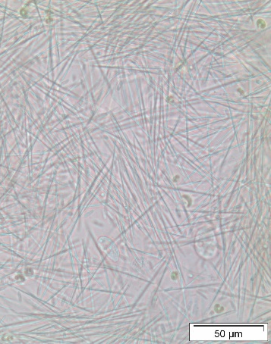
D
C
B
A

S1 Fig. Stages of Metschnikowia bicuspidata infection in Daphnia galeata × longispina.
(A) healthy, uninfected female; (B) early development of infection signs – body becomes more opaque with the presence of ascospores (not all of them mature yet); (C) late development of infection signs – body cavity is filled with needle-like ascospores; (D) detail of ascospores released by dead hosts.

